Sigma Banking System
How to Use the Sigma Banking System
The Sigma Banking System is a banking application that assists customers in creating, deleting, depositing, withdrawing, and remitting bank accounts. In this section, the detailed process of operating this system from the menu page is described.
- Starting the Program
To start the Sigma Banking System:
- Open a Terminal on your device
- Navigate to the program folder
- Run the executable
It is crucial to run the program inside the banking-system-c directory as the application accesses the database files using relative path.
Once you execute the program, it will:
- Show the current data and time
- Show many accounts exist in the system
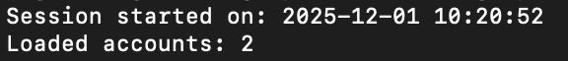
Then, you can view the main menu.
- Main Menu
In Sigma Banking System, there are 6 choices:
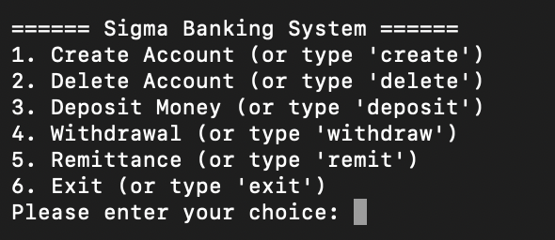
Placing the number or keyword of the option in the bracket () allows you to choose that option.
(e.g., typing 1 or delete is the same)
- Creating an Account
Selecting Create Account will prompt you to enter:
- Full Name
- Only letters and spaces are permitted
- 3 attempts to enter correctly or otherwise it will return to the menu session
- Identification Number (8 digits)
- Must be exactly 8 numbers
- 3 attempts to enter correctly or otherwise it will return to the menu session
- Account Type
- Savings or Current (not case sensitive)
- 4-digit PIN
- Must have exactly 4 numbers
If all information is valid, the system will:
- Generate a 7–9-digit account number
- Create a new account file in the database folder
- Store the account number in the index
- Show the new account details
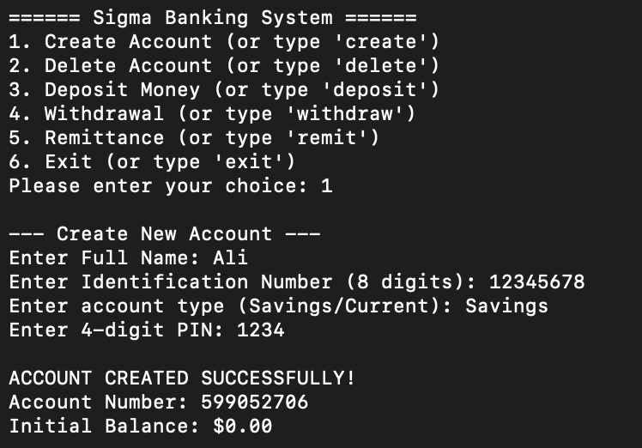
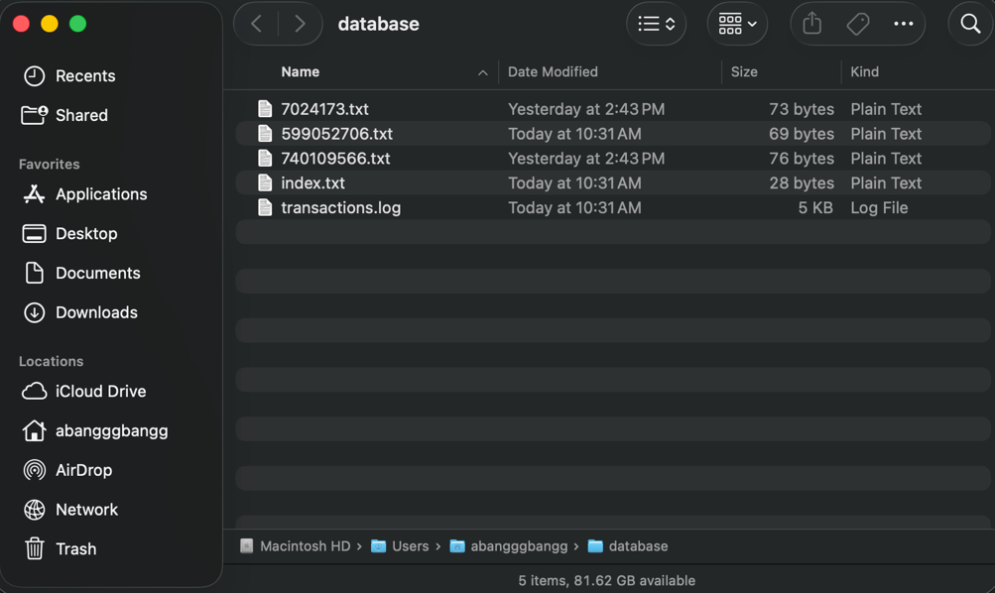
- Deleting an Account
Selecting Delete Account will display all existing accounts.
In order to delete an account, you must:
- Enter the account number
- Enter the last 4 digits of the ID
- Enter the PIN
- To verify deletion, type y (yes)
All inputs are given 3 attempts. Otherwise, it will return to the menu session.
After confirming delete an account, the account file is deleted, and the index file is updated.
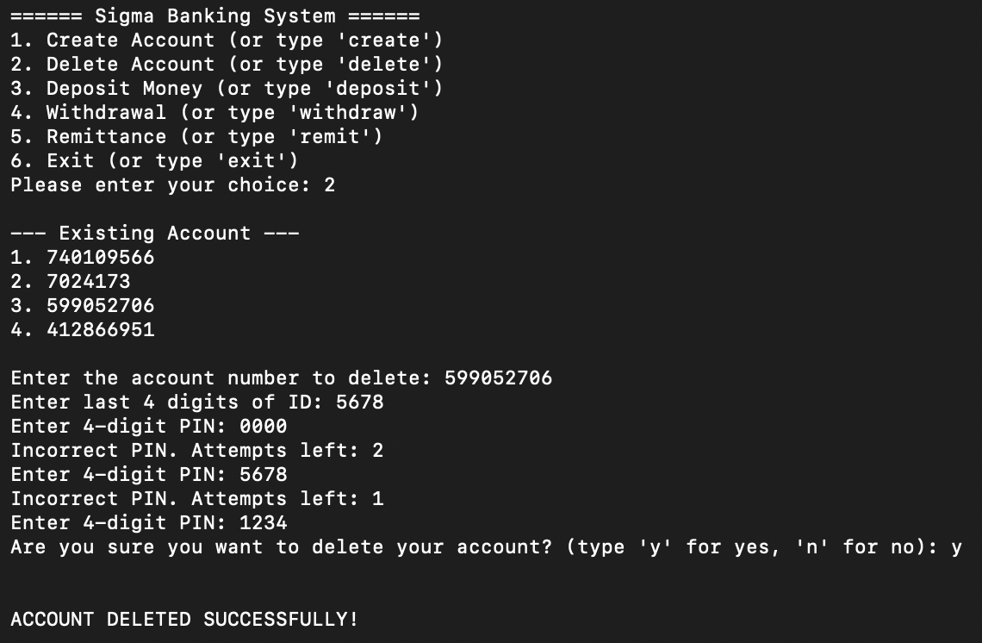
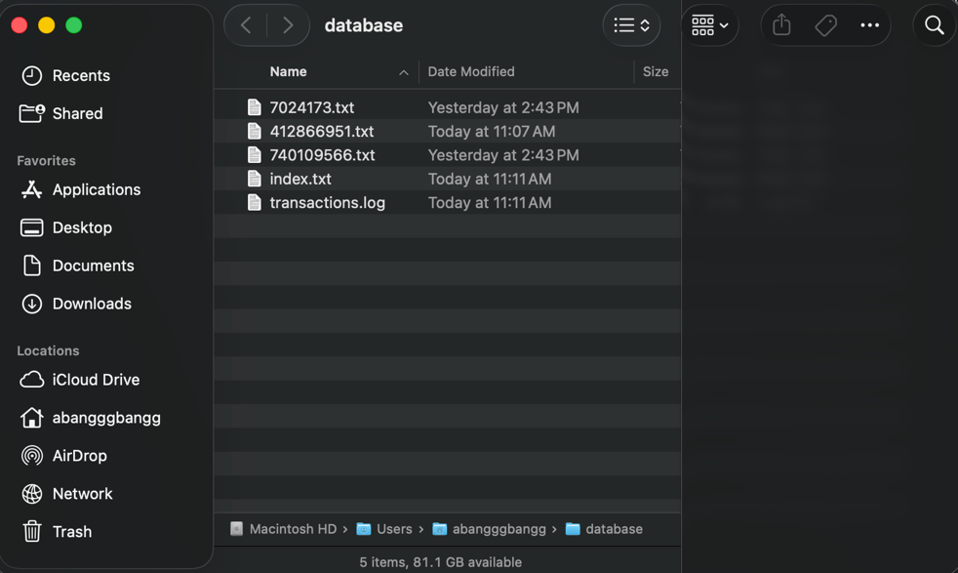
- Depositing Money
Selecting Deposit Money will:
- Display all account numbers
- Requests your account number
- Ask for the PIN
- Ask for the deposit amount (max $50,000)
If every inputs is entered correctly, the system will update the balance.
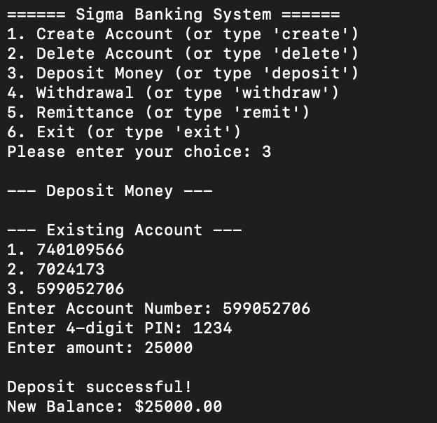
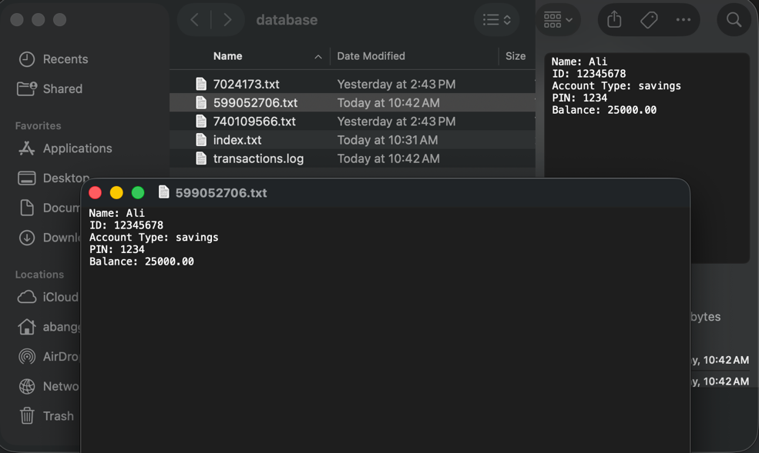

- Withdrawing Money
Withdraw function steps:
- Display all account numbers
- Enter PIN
- System displays current balance
- Enter amount to withdraw (max $50,000)
- Ensure balance is sufficient
If every input is entered correctly, the system will update the balance.
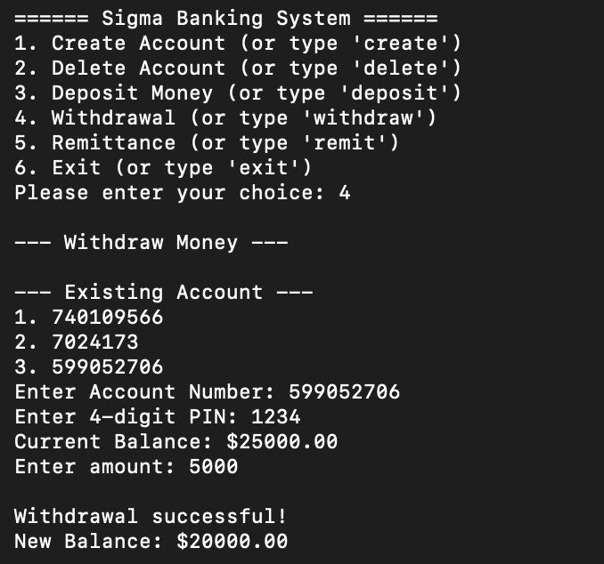
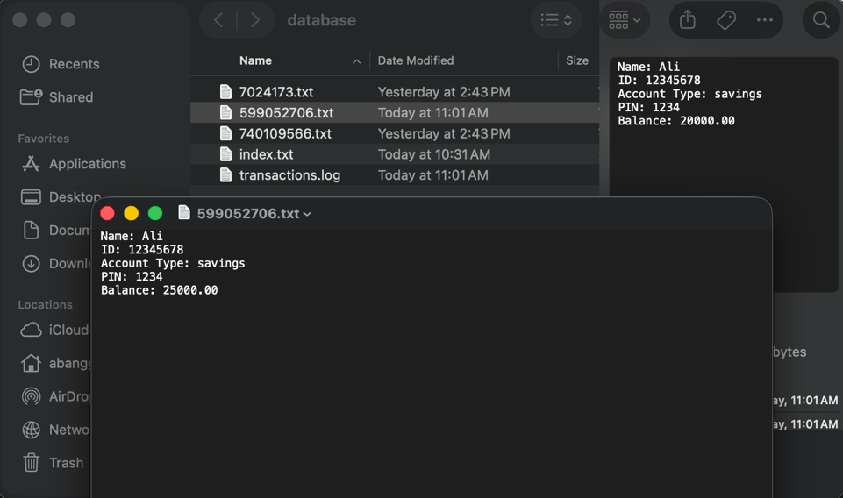
- Remittance (Sending Money Between Accounts)
This option allows you to transfer funds from one account to another.
Steps:
- Select the sender account
- Enter sender PIN
- Enter receiver account number
- Must be valid and. Not the same as sender
- 3 attempts allowed
- System displays current balance of sender
- Enter amount to remit
- Fee is calculated based on account types:
- Savings → Current: 2% fee
- Current → Savings: 3% fee
- Same type: No fee
- System updates both accounts
